Game Background :

C-DOTA is a RPG (Role Play Game) and SLG (Simulation Game).

It pits two teams of players against each other: the Sentinel and the Scourge.

Players on the Sentinel team are based at the southwest corner of the map, and those on the Scourge team are based at the northeast corner.

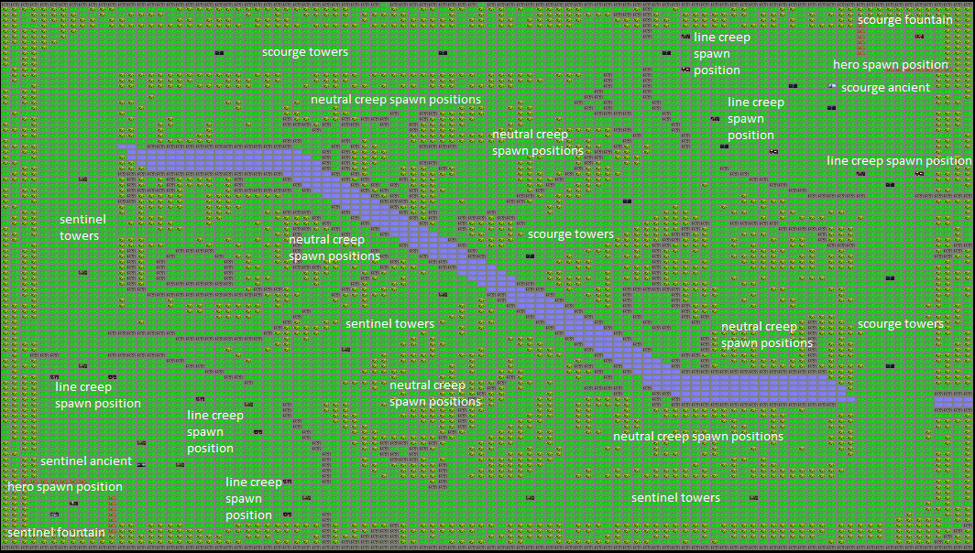Each base is heavily guarded by towers and waves of line creeps which guard the main paths leading to their base.

Players use powerful units known as heroes, and are assisted by allied heroes and AI-controlled fighters. As in role-playing games, players level up their heroes and use gold to buy equipment during the mission.

Winning / Losing condition :

In the center of each base is the "Ancient", a building that must be destroyed to win the game.

How to play :